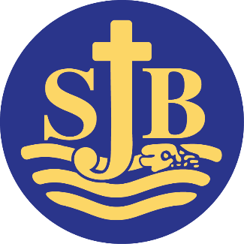
Website: www.stjohn.brighton-hove.sch.uk Headteacher: Carly Carden MA
ST. JOHN THE BAPTIST

CATHOLIC PRIMARY SCHOOL

Diocese of Arundel & Brighton
Whitehawk Hill Road
Brighton BN2 0AH

TEACHING ASSISTANT (Level B) / MIDDAY SUPERVISOR

St John the Baptist is a one form entry school with approximately 200 pupils on roll. We pride ourselves on our positive and inclusive, approach. We have a vacancy for a Teaching Assistant/Individual Needs Assistants (Level B) . The role also involves lunchtime supervision (see separate job description).

Hours: 24.hrs 35minutes per week, over 5 days Teaching Assistant (TA)
4hrs 10 minutes per week, over 5 days Midday Supervisor

Pay Scale
NJC Scale 10 TA £28608 (pro rata 47.36 weeks)-Actual £17311.51
NJC Scale 8 Midday Supervisor £27709 (pro rata 43.89 weeks) Actual £2633.72

We are looking for candidates who have the NVQ 2 Teaching Assistant’s qualification and /or recent experience of working in a primary school or nursery school. The successful candidate will be fully committed to supporting the Catholic ethos of our school. They will also:

- Be enthusiastic and passionate about supporting children’s learning.
- Have some experience of working with children with special needs including autism
- Have excellent communication skills and a calm and patient approach
- Be keen to work with others as part of a team
- Have excellent time-management and organisational skills
- Be flexible as may be required to undertake Individual Needs Assistant tasks as directed.
We will offer you:
- Children who are genuinely a pleasure to teach, enjoy school and work hard.
- A happy working environment with a positive and inclusive ethos.
- A strong, committed and collaborative staff team.
- Opportunities for training and further development.
St John the Baptist Catholic Primary School is committed to safeguarding and promoting the welfare of children and young people and expects all staff and volunteers to share this commitment. This post will be subject to an enhanced criminal records bureau disclosure check.
Visits to the school are welcome, please telephone 01273 607924 or email clairemcgrath@stjohn.brighton-hove.sch.uk to make an appointment.




Closing date: Midday, Wednesday 30th September Interview date: Wednesday 7th October (am)





-----------------------------------
Telephone (01273) 607924 e-mail: admin@stjohn.brighton-hove.sch.uk

